**ST.XAVIER’S COLLEGE**

MAITIGHAR, KATHMANDU



**Computer Graphics Assignment #9**

**Shear an image**

**Submitted By:**

Bikash Paneru

013BSCCSIT012

**Submitted to:**

|  |  |
| --- | --- |
| Er. Anil K. Sah  Lecturer, Department of Computer Science |  |

**Date of Submission:** 8 September, 2015

**STATEMENT**

Write a program to Shear an image.

­

**SOURCE CODE**

//---------------------------------------------------------------------------

#include <vcl\vcl.h>

#pragma hdrstop

#include "Unit1.h"

//---------------------------------------------------------------------------

#pragma resource "*.dfm"

TShearing *Shearing;

//---------------------------------------------------------------------------

__fastcall TShearing::TShearing(TComponent* Owner)

: TForm(Owner)

{

}

//---------------------------------------------------------------------------

void __fastcall TShearing::shearClick(TObject *Sender)

{

int height = drawArea->Height;

int width = drawArea->Width;

int heightHlf = height/2;

TCanvas * sourceImg = source->Canvas;

TCanvas * destination = drawArea->Canvas;

destination->FillRect(ClientRect);

float xSh;

float ySh;

try {

xSh = StrToFloat(shearX->Text);

} catch (EConvertError &e) {

xSh=0;

}

try {

ySh = StrToFloat(shearY->Text);

} catch (EConvertError &e) {

ySh=0;

}

for(int y=0;y<height;++y) {

for(int x=0;x<width;++x) {

int _x = x+xSh*y;

int _y = y+ySh*x;

destination->Pixels[_x][_y]=sourceImg->Pixels[x][y];

}

}

}

//---------------------------------------------------------------------------

**OUTPUT:**

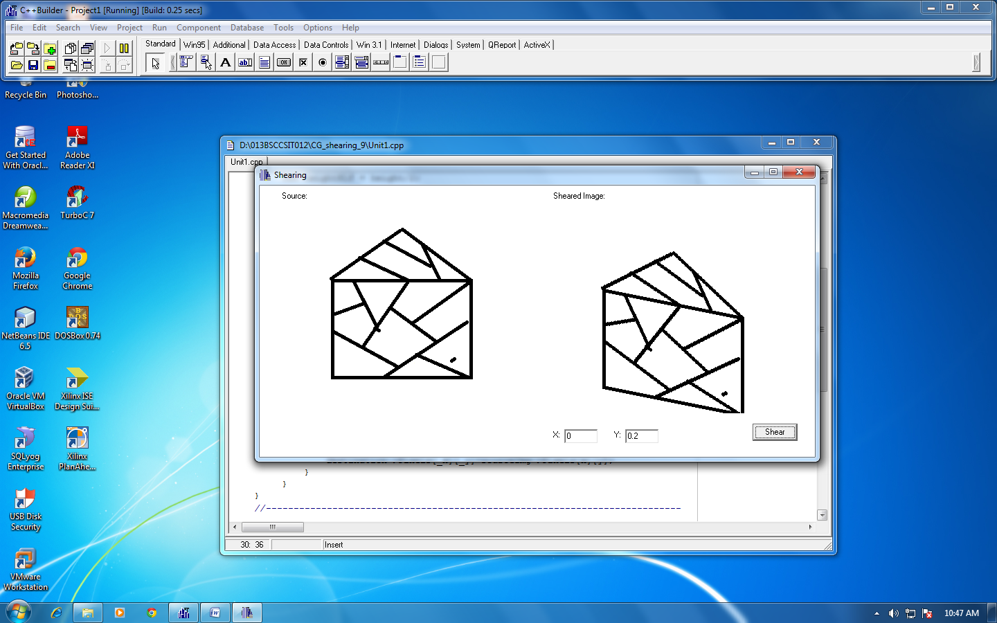

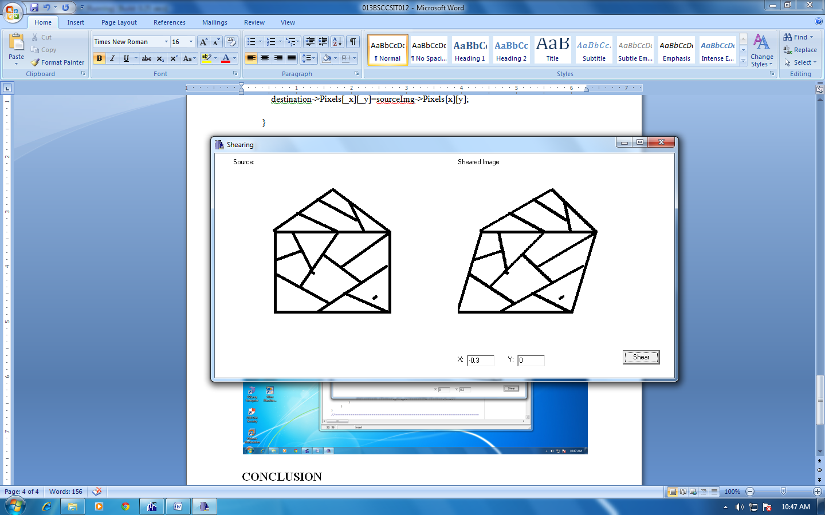

**CONCLUSION**

Hence, a program to shear an image was implemented by using C++ with C++Builder.